CT60A5103 Software Engineering Models and Modeling
Final project submission
Case: AudioNow

Hyechan Shin
Robert Gabrielsson

Introduction
We chose the AudioNow as a main project case and selected the Incremental Model for our software engineering process model. As client is expecting to this project to be completed within 12 months, with the incremental approach, the product is being added piece by piece, allow us to see the results each month. This will help us to focus on where to allocate resources more effectively and efficiently throughout the project.

The Incremental Process Model
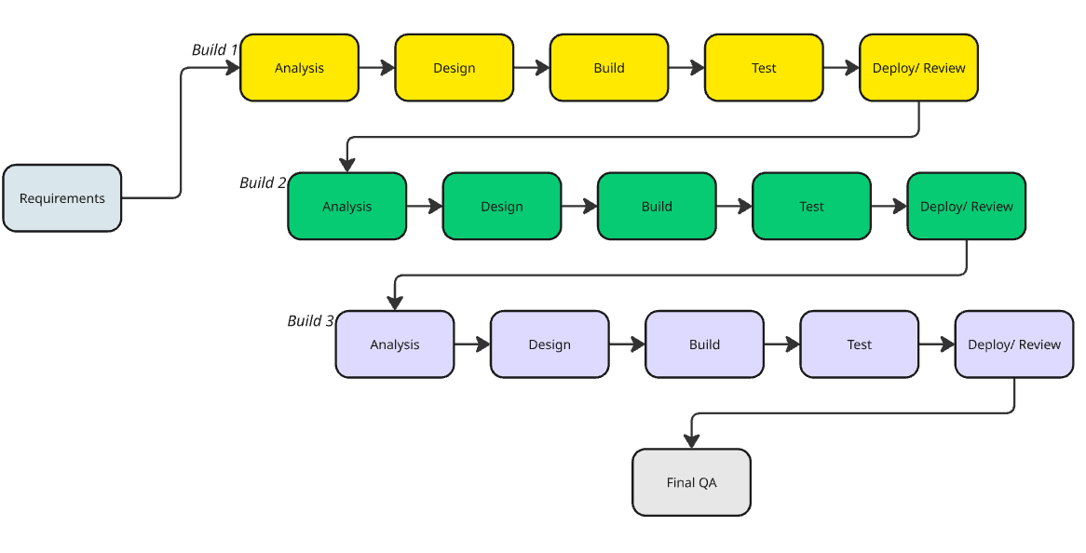Starting with gathering the high-level requirements from the AudioNow system will allow us to build our core structure before building each increment. Build 1, 2 and 3 are part of the increment and it includes five stages: Analysis, Design, Build, Test, Deploy/ Review, repeated for every increment until the final QA.

Timeline for deadlines
Phase | Months | Note
Requirement + PoC | 1-2 | Gather enough requirement and proof of concept
Build 1 | 2-5 | Core feature development
Build 2 | 5-8 | Expand core feature
Build 3 | 8-11 | Wrap up final features
Final QA | 11-12 | Final testing and validating all features are complete
*All build require monthly client review

Documents & Artifacts
Text

Testing & Metrics
Text

Clarification of AI Usage
ChatGPT was used to getting the rough idea of timeline for deadlines.

Reference
GeeksforGeeks. (2020, September 17). Difference between Spiral model and Incremental model. GeeksforGeeks. https://www.geeksforgeeks.org/software-engineering/difference-between-spiral-model-and-incremental-model/

---Assignment descriptions---

General requirements

Max 2 pages (+1 cover page). Please concentrate on designing a good process model, explaining it, and detailing the deliverables listed below at a general level. When designing, think about why the case company (see full project assignment) needs it and its relationship to the project.

Submit this assignment via Moodle as PDF (see the exercises and assignment page for the return link)

If accepted, you may revise and include this deliverable as part of the final version of the course project report.

Assignment introduction and motivation

Some companies have technical or artistic talent, but they are unfamiliar with how to organize for software engineering and how to set up their software engineering process. In this case, imagine yourself as consultants who help the company described below to set up and customize a software engineering process for their use.

In the case described below, you are consultants hired by the case company to help design a process that meets design requirements.

Case description

In this case, you and your team are a new software consultancy and has just received their first project assignment, or the course project case. During the bidding process, your client requests the following information and schedules.

· A proof-of-concept demo and full design documentation before the approval of further development work. Design can be modified during the development based on the feedback.

· A test plan for quality assurance including testing with the real target audience users

· Monthly reviews on progress, including review data from user testing

· Proof that the work is actually supervised, and that there is management of daily tasks

· The project has to be completed in 12 months, of which 1 month has to be reserved for quality assurance and acceptance testing only.

· Client pays for reasonable amount of working hours only and is not willing to pay salary for more than 10 people.

You can hire a maximum of 7 people, of which 3 are mainly developers and 3 mainly artists. The seventh person is mostly occupied by the sales and management tasks, but in reality currently everyone does a bit of everything. Your consultancy already has access to the necessary tools and object libraries and other assets to technically construct the product.

Case assignment

This is where your team is brought in. You task is to create a process model, deadlines, document specifications and internal schedule for the software consultancy to use and apply on their project. Define how the development work should be done, what metrics should be collected, what things should be tested (and how they should be tested), and what things has to be documented. Draw a process model diagram, define internal deadlines for each phase, and define the necessary documents on the “table of content”-level. Also explain why you chose those particular ways to do the work.

Deliverables

Write a short document that describes a software engineering process model that your team has planned. Minimally, include following in the process document.

The software engineering process model and the rationale for selecting it (see course literature)
What steps are in the process model, what deadlines are in the process (internal schedule), and what things are documented each step.
Briefly describe each document or artefact that is outputted (e.g. design or QA document). Do not describe actual content, but describe the rough structure and its purpose.
Testing and metrics - where do they occur and how they are reported by a) developers to consultancy and b) consultancy to client?
For other components to include in the assignment, read the case assignment and case description carefully. The client company requires several documents and artefacts from your consultancy.

Return the group work via course Moodle page with the document as one pdf file, including the PDF file. If you are experiencing problems, please contact the course lecturer.

Q&A
In this part, we have collected some questions previously asked by students.

Q: I am unsure how to get started.
A: Review Sommerville on software process models and how Sommerville's coursebook and slides have pictured software process models. The first part of topic 2 lectures (Sommerville on fundamental software engineering activities) is also a good part to start watching.

Q: What is a software process model diagram?
A: In this assignment, you do not have to use any specific modeling language. Have a look at the visual examples and then create your own.

Q: Do I need to design the software product itself or for example draw prototype visuals?
A: No. Just describe what is the purpose of the prototype and what content a prototype should have.

